**EVENT MANAGEMENT SYSTEM**

**Software Design Document**

– HoChiMinh, November 2021 –

**Table of Contents**

I. Overview....................................................................................................................... 3

1. Code Packages....................................................................................................... 3

2. Database Schema................................................................................................... 6

II. Database Tables........................................................................................................... 9

# **I. Overview**

## **1. Code Packages/Namespaces**

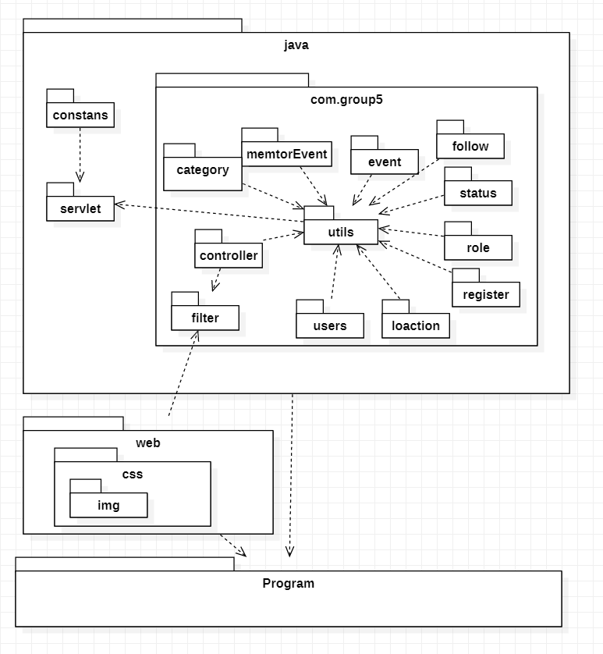

***Package descriptions & package class naming conventions***

|  |  |  |
| --- | --- | --- |
| **No** | **Package** | **Description** |
| 01 | web | This package contains jsp page of all type of user , package css ,and img  index.jsp |
| 02 | css | This package contains css code and img package to style all jsp page  homePageStyle.css |
| 03 | img | This package contains image for all jsp page  1.jpg |
| 04 | constans | This package contains account information from google.  constans.java |
| 05 | servlet | This package contains code to get account information from google.  LoginGoogleHandler.java |
| 06 | filter | This package contains a class to authenticate and authorize user or validate data before forward the request to controller layer.  AuthenticationFilters.java |
| 07 | controller | This package contains classes to provide service to the user.  MainController.java |
| 08 | utils | This package contains classes to support other layers to do their jobs such as translating error messages, getting server configuration, or validation schema.  DBUtils.java |
| 09 | category | This package contains class containing category information, and class contains code to get those information.  CategotyDTO.java |
| 10 | memtorEvent | This package contains class containing which event mentor attended information, and class contains code to get those information.  MentorEventDTO.java |
| 11 | event | This package contains class containing event, followup , Q&A information, and class contains code to get those information.  EventDTO.java |
| 12 | follow | This package contains class containing follower information, and class contain code to get those information.  FollowDTO.java |
| 13 | status | This package contains class containing status information, and class contains code to get those information.  StatusDTO.java |
| 14 | role | This package contains class containing role information, and class contains code to get those information.  RoleDTO.java |
| 15 | register | This package contains class containing register information, and class contains code to get those information.  RegisterDTO.java |
| 16 | location | This package contains class containing location information, and class contains code to get those information.  LocationDTO.java |
| 17 | users | This package contains class containing users information, and class contains code to get those information.  UserDTO.java |

## **2. Database Schema**

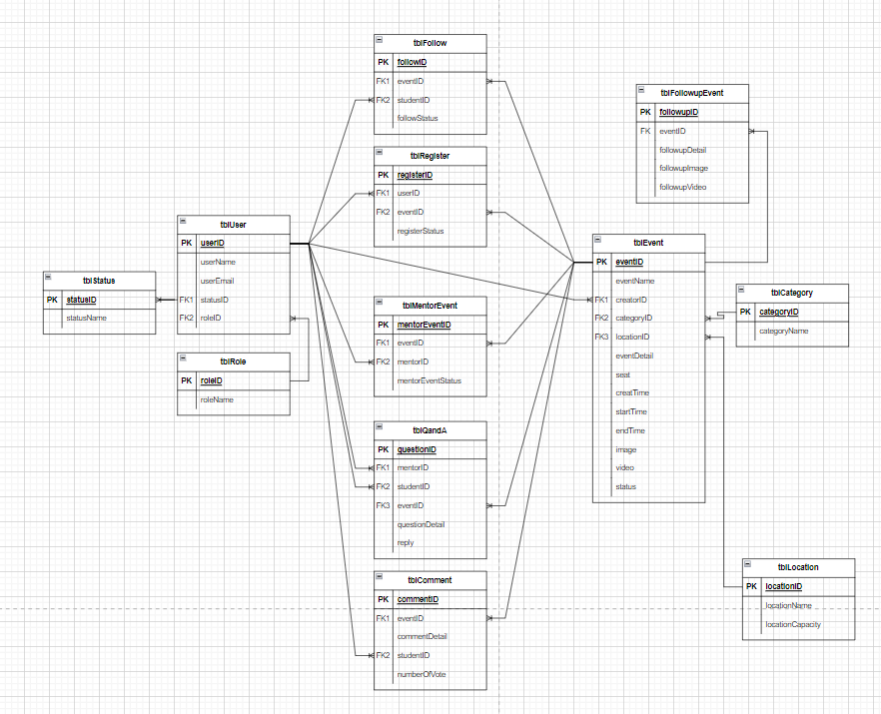

***Table descriptions & package class naming conventions are as below***

|  |  |  |
| --- | --- | --- |
| **No** | **Table** | **Description** |
| 01 | tblEvent | *-* Primary keys: eventID  - Foreign keys: creatorID, categoryID, locationID  - Other attribute: eventName, eventDetail, seat, creatTime, startTime, endTime, image, video, status |
| 02 | tblUser | *-* Primary keys: userID  - Foreign keys: statusID, roleID  - Other attribute: userName, userEmail |
| 03 | tblFollow | *-* Primary keys: followID  - Foreign keys: eventID, studentID  - Other attribute: followStatus |
| 04 | tblRegister | *-* Primary keys: registerID  - Foreign keys: userID, eventID  - Other attribute: registerStatus |
| 05 | tblComment | *-* Primary keys: commentID  - Foreign keys: eventID, studentID  - Other attribute: commentDetail, numberOfVote |
| 06 | tblFollowupEvent | *-* Primary keys: followupID  - Foreign keys: eventID  - Other attribute: followupDetail, followupImage, followupVideo |
| 07 | tblQandA | *-* Primary keys: questionID  - Foreign keys: mentorID, studentID, eventID  - Other attribute: questionDetail, reply |
| 08 | tblLocation | *-* Primary keys: locationID  - Other attribute: locationName, locationCapacity |
| 09 | tblRole | *-* Primary keys: roleID  - Other attribute: roleName |
| 10 |  | *-* Primary keys: userID  - Foreign keys: statusID, roleID  - Other attribute: userName, userEmail |
| 11 | tblStatus | *-* Primary keys: statusID  - Other attribute: statusName |
| 12 | tblCategory | *-* Primary keys: categoryID  - Other attribute: categoryName |
| 13 | tblMentorEvent | *-* Primary keys: mentorEventID  - Foreign keys: eventID, mentorID  - Other attribute: mentorEventStatus |

# 

# **II. Database Tables**

## **1. tblEvent**

|  |  |  |  |  |  |  |  |
| --- | --- | --- | --- | --- | --- | --- | --- |
| **#** | **Field name** | **Type** | **Size** | **Unique** | **Not Null** | **PK/FK** | **Notes** |
| 1 | eventID | nvarchar(50) | 100 Bytes |  | x | PK | Id of an event |
| 2 | eventName | text | 2GB |  |  |  | Name of an event |
| 3 | creatorID | nvarchar(50) | 100 Bytes |  |  | FK | Id of creator this event |
| 4 | categoryID | nvarchar(50) | 100 Bytes |  |  | FK | Category of event |
| 5 | locationID | nvarchar(50) | 100 Bytes |  |  | FK | Location venue |
| 6 | eventDetail | nvarchar(MAX) | 2GB |  |  |  | Description of event |
| 7 | seat | int | 4 Bytes |  |  |  | Quantity student can attend the event |
| 8 | creatTime | datetime | 8 Bytes |  |  |  | Time to create event |
| 9 | startTime | datetime | 8 Bytes |  |  |  | Time to start event |
| 10 | endTime | datetime | 8 Bytes |  |  |  | Time to end event |
| 11 | image | text | 2GB |  |  |  | Poster of event |
| 12 | video | text | 2GB |  |  |  | Video to description event |
| 13 | status | nvarchar(10) | 20 Bytes |  |  |  | Status of event(upcoming,...) |

## **2. tblUser**

|  |  |  |  |  |  |  |  |
| --- | --- | --- | --- | --- | --- | --- | --- |
| **#** | **Field name** | **Type** | **Size** | **Unique** | **Not Null** | **PK/FK** | **Notes** |
| 1 | userID | nvarchar(50) | 100 Bytes |  | x | PK | Id of user |
| 2 | userName | nvarchar(50) | 100 Bytes |  |  |  | Name of user |
| 3 | userEmail | text | 2GB |  |  |  | Email of user |
| 4 | statusID | nvarchar(10) | 20 Bytes |  |  | FK | Id of status |
| 5 | roleID | nvarchar(10) | 20 Bytes |  |  | FK | Id of role user |

## **3. tblFollow**

|  |  |  |  |  |  |  |  |
| --- | --- | --- | --- | --- | --- | --- | --- |
| **#** | **Field name** | **Type** | **Size** | **Unique** | **Not Null** | **PK/FK** | **Notes** |
| 1 | followID | nvarchar(50) | 100 Bytes |  | x | PK | Id of follow |
| 2 | eventID | nvarchar(50) | 100 Bytes |  |  | FK | Id of event |
| 3 | studentID | nvarchar(50) | 100 Bytes |  |  | FK | Id of student |
| 4 | followStatus | nvarchar(50) | 100 Bytes |  |  |  | Status of follow |

## 

## **4. tblRegister**

|  |  |  |  |  |  |  |  |
| --- | --- | --- | --- | --- | --- | --- | --- |
| **#** | **Field name** | **Type** | **Size** | **Unique** | **Not Null** | **PK/FK** | **Notes** |
| 1 | registerID | nvarchar(50) | 100 Bytes |  | x | PK | Id of register |
| 2 | userID | nvarchar(50) | 100 Bytes |  |  | FK | Id of user |
| 3 | eventID | nvarchar(50) | 100 Bytes |  |  | FK | Id of event |
| 4 | registerStatus | nvarchar(10) | 20 Bytes |  |  |  | Status of register |

## **5. tblComment**

|  |  |  |  |  |  |  |  |
| --- | --- | --- | --- | --- | --- | --- | --- |
| **#** | **Field name** | **Type** | **Size** | **Unique** | **Not Null** | **PK/FK** | **Notes** |
| 1 | commentID | nvarchar(50) | 100 Bytes |  | x | PK | Id of comment |
| 2 | eventID | nvarchar(50) | 100 Bytes |  |  | FK | Id of event |
| 3 | commentDetail | text | 2GB |  | x |  | Content of comment |
| 4 | studentID | nvarchar(50) | 100 Bytes |  |  | FK | Id of student |
| 5 | numberOfVote | int | 4 Bytes |  |  |  | Quantity of vote |

## 

## **6. tblFollowupEvent**

|  |  |  |  |  |  |  |  |
| --- | --- | --- | --- | --- | --- | --- | --- |
| **#** | **Field name** | **Type** | **Size** | **Unique** | **Not Null** | **PK/FK** | **Notes** |
| 1 | followupID | nvarchar(50) | 100 Bytes |  | x | PK | Id of follow-up |
| 2 | eventID | nvarchar(50) | 100 Bytes |  |  | FK | Id of event |
| 3 | followupDetail | nvarchar(50) | 100 Bytes |  |  |  | Description of follow-up |
| 4 | followupImage | text | 2GB |  |  |  | Image of follow-up |
| 5 | followupVideo | text | 2GB |  |  |  | Video of follow-up |

## 

## **7. tblQandA**

|  |  |  |  |  |  |  |  |
| --- | --- | --- | --- | --- | --- | --- | --- |
| **#** | **Field name** | **Type** | **Size** | **Unique** | **Not Null** | **PK/FK** | **Notes** |
| 1 | questionID | nvarchar(50) | 100 Bytes |  | x | PK | Id of question |
| 2 | mentorID | nvarchar(50) | 100 Bytes |  | x | FK | Id of mentor |
| 3 | studentID | nvarchar(50) | 100 Bytes |  | x | FK | Id of student |
| 4 | eventID | nvarchar(50) | 100 Bytes |  | x | FK | Id of event |
| 5 | questionDetail | text | 2GB |  | x |  | Content of question |
| 6 | reply | nvarchar(MAX) | 2GB |  |  |  | Answer of question |

## **8. tblLocation**

|  |  |  |  |  |  |  |  |
| --- | --- | --- | --- | --- | --- | --- | --- |
| **#** | **Field name** | **Type** | **Size** | **Unique** | **Not Null** | **PK/FK** | **Notes** |
| 1 | locationID | nvarchar(50) | 100 Bytes |  | x | PK | Id of location |
| 2 | locationName | nvarchar(50) | 100 Bytes |  |  |  | Name of location |
| 3 | locationCapacity | int | 4 Bytes |  |  |  | Capacity of location |

## **9. tblRole**

|  |  |  |  |  |  |  |  |
| --- | --- | --- | --- | --- | --- | --- | --- |
| **#** | **Field name** | **Type** | **Size** | **Unique** | **Not Null** | **PK/FK** | **Notes** |
| 1 | roleID | nvarchar(10) | 20 Bytes |  | x | PK | Id of role user |
| 2 | roleName | nvarchar(50) | 100 Bytes |  |  |  | Name of role |

## **10. tblStatus**

|  |  |  |  |  |  |  |  |
| --- | --- | --- | --- | --- | --- | --- | --- |
| **#** | **Field name** | **Type** | **Size** | **Unique** | **Not Null** | **PK/FK** | **Notes** |
| 1 | statusID | nvarchar(10) | 20 Bytes |  | x | PK | Id of status |
| 2 | statusName | nvarchar(50) | 100 Bytes |  |  |  | Name of status |

## **11. tblCategory**

|  |  |  |  |  |  |  |  |
| --- | --- | --- | --- | --- | --- | --- | --- |
| **#** | **Field name** | **Type** | **Size** | **Unique** | **Not Null** | **PK/FK** | **Notes** |
| 1 | categoryID | nvarchar(50) | 100 Bytes |  | x | PK | Id of category |
| 2 | categoryName | nvarchar(50) | 100 Bytes |  |  |  | Name of category |

## **12. tblMentorEvent**

|  |  |  |  |  |  |  |  |
| --- | --- | --- | --- | --- | --- | --- | --- |
| **#** | **Field name** | **Type** | **Size** | **Unique** | **Not Null** | **PK/FK** | **Notes** |
| 1 | mentorEventID | nvarchar(50) | 100 Bytes |  | x | PK | Id of mentorEvent |
| 2 | eventID | nvarchar(50) | 100 Bytes |  |  | FK | Id of event |
| 3 | mentorID | nvarchar(50) | 100 Bytes |  |  | FK | Id of mentor |
| 4 | mentorEventStatus | nvarchar(10) | 20  Bytes |  |  |  | Status of mentorEvent |